

**Carrier CACI12OC3I6 1 Ton**

**Rs. 146,300/-**

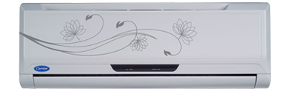

**Product Features**

* Antifouling and Movable Baffle
* Compact Design
* 3D airflow
* Rounding Natural Air
* Built In High Head Drain Pump

**Specification**

**Type** Wall Mounted Split AC

**Cooling (Btu/h)** 42000

**Voltage (V)** 220-240

**Power Input (W)** 4200

**EER (Btu/W-h-W/W)** 8.1-3.85